Architecture Design
for
Transport Company Management System
Version 1.1 approved
Prepared by Ploae Darius-Adonis-Ionuț
Popa-Ion Andrei
Șerban Alexandru-Cristian-George
UCV
17th March 2026
Table of Contents
Table of Contents ii
Revision History ii
1. Use-Case 1
2. Activity Diagram 2
3. Class Diagram 4
4. Entity Relationship Diagram + Relational Model 5
5. Task list 6

Revision History
Name | Date | Reason For Changes | Version
Ploae Darius-Adonis-Ionut  Serban Alexandru-Cristian-George | 17.03.2026 | Initial document creation for Architecture Design | 1.0
Ploae Darius-Adonis-Ionut  Serban Alexandru Cristian-George  Popa-Ion Andrei | 22.03.2026 | Completing the relational model + tasks list in Jira | 1.1

Use-Case

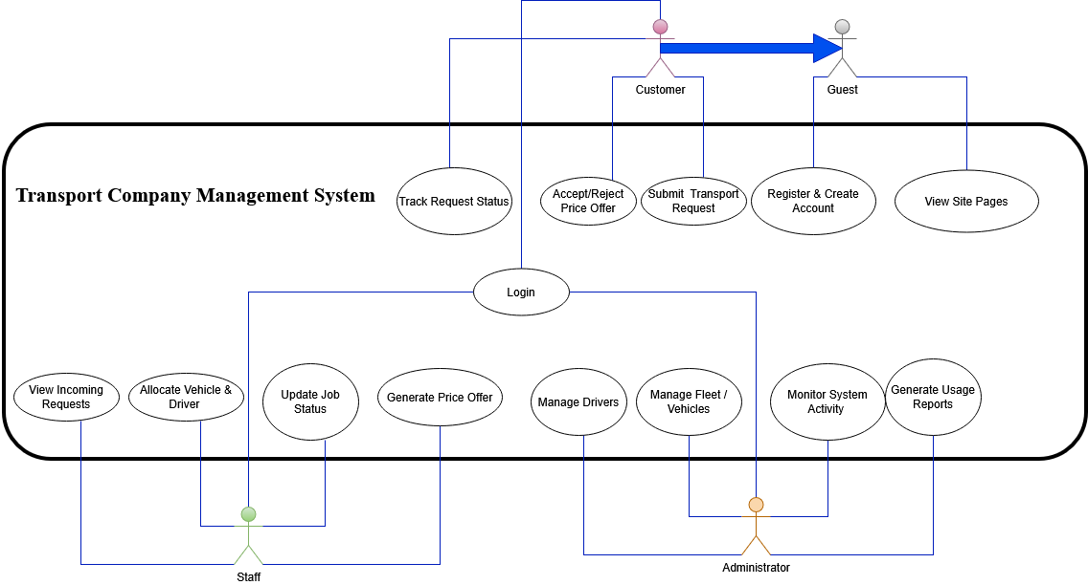

Activity Diagram

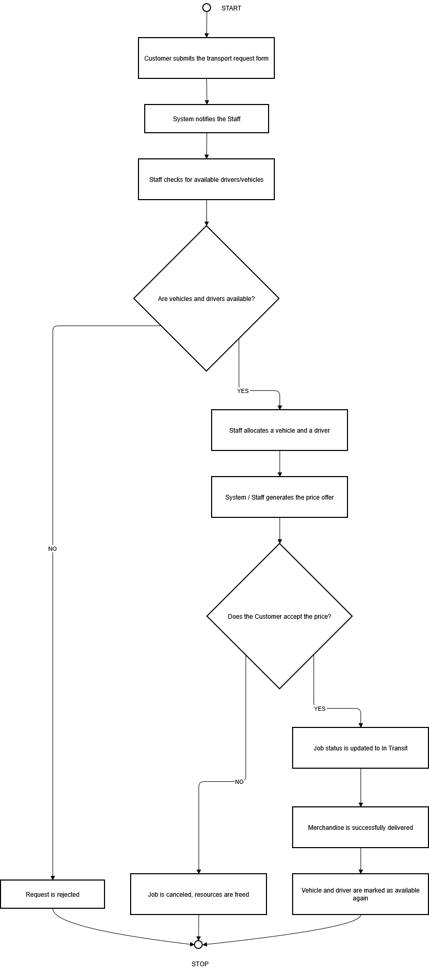

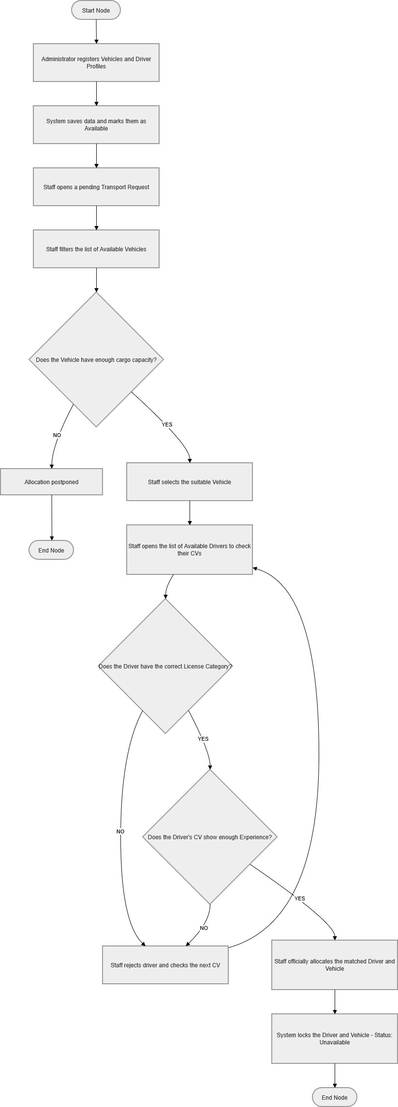

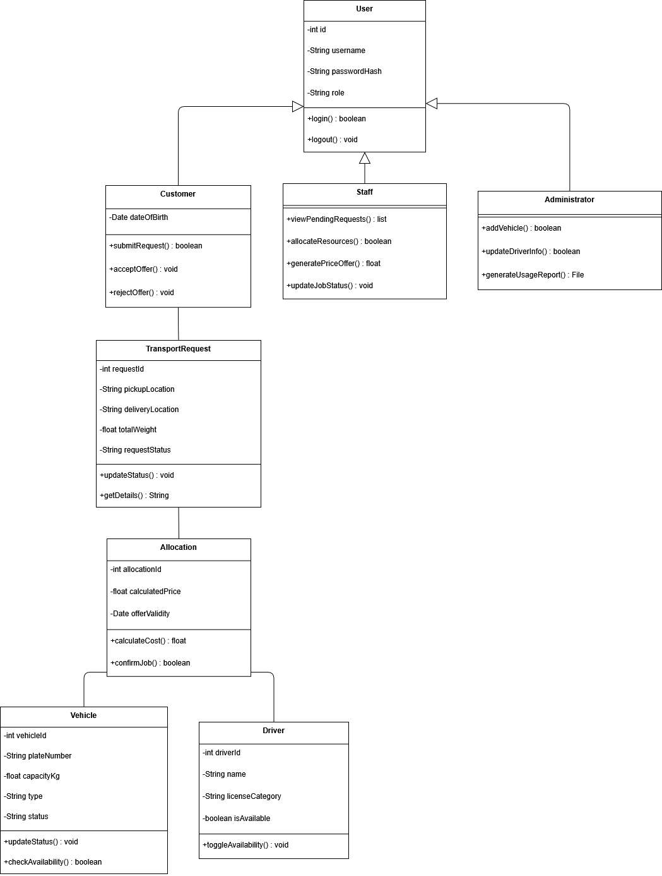
Class Diagram

Entity Relationship Diagram + Relational Model
ERD for Transport Company Management System Chen style

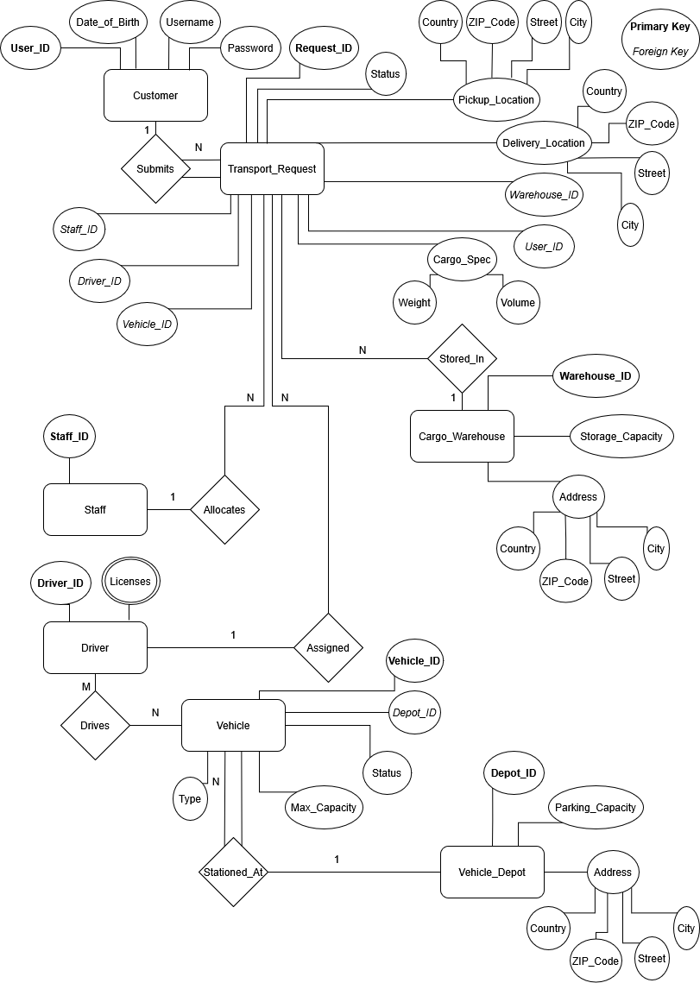

Relational Model for Transport Company Management System based on the ERD

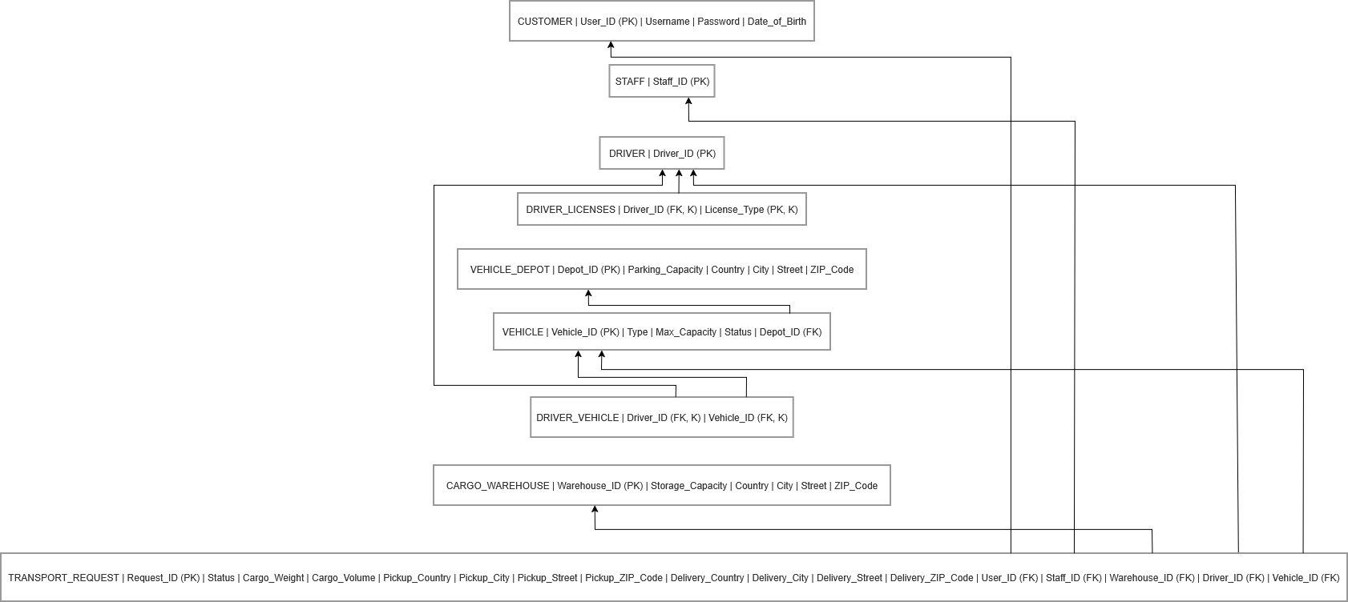

Task list
https://transport-company-management-system.atlassian.net/jira/software/projects/DEV/boards/2

